TRAIL OF TEARS- Movie Guide
NAME____________________________________ DATE ______________ HOUR ___________
Chapter One, A Civilized Life Preserving the Cherokee Nation; John Ross
1. Compare the Cherokee nation of John Ridge’s youth to that of 1805. What forces threatened his people?

Map 1: the Cherokee Nation in 1771
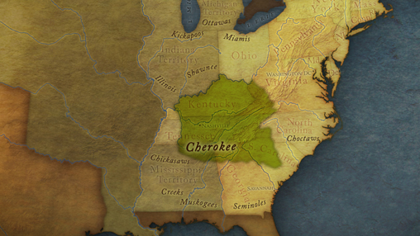
Map 2: the Cherokee Nation in 1805
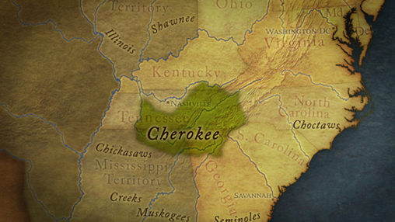
2. What was the U.S. government policy of “civilization” and how was it introduced to the Cherokees?

3. John Ross was a mixed-blood Cherokee. Describe the various types of people that entered his family’s store.

Chapter Two, Among the White People
John Ridge
4. What was Major Ridge’s hope for the future?

5. Where were John Ridge and Elias Boudinot sent to be educated? What did the assimilated John Ridge tell President James Monroe in his essay?

6. What did John Ridge do to win over Sarah’s parents and what was the community response in Cornwall to their marriage? How did this change John Ridge?

Chapter Three, Cherokee Nation on the Rise Cherokee literacy, constitution, and sovereignty
7. What pressures did John Ross see threatening the Cherokee Nation? What was his reaction to these pressures?

8. Who among the Cherokees owned slaves?

9. How did the lives of traditional Cherokees differ from that of the Ridge family?

10. What did Sequoyah do that no one had ever done before? How did a written language revolutionize Cherokee society?

11. In the 1820s how did the Cherokee nation rise and prosper?

12. What were some of the elements of the Cherokee constitution that John Ross authored in 1827?

13. What effect did strong Cherokee unity and the tribe's declaration of absolute sovereignty of their lands have on the white people of Georgia?

Chapter Four, "I Ask You, Shall Red Men Live?" Andrew Jackson, states' rights, and the Indian Removal Bill
14. What two events occurred that was disastrous for the Cherokees?

15. What was President Andrew Jackson’s first priority and how did he accomplish it?

16. What did the Cherokees do as other tribes prepared for removal?

17. What happened after the Indian Removal Bill passed? How did the state of Georgia respond?

18. Newly elected as Principal Chief, John Ross rewrote the blood law. What was its purpose?

19. The Cherokees filed more than a dozen suits in federal court; two made it to the Supreme Court. What was the question at the center of those two cases?

20. What happened in Worcester v. Georgia?
21. Which Chief Justice of the Supreme Court wrote the opinion?

22. John Ridge visited Andrew Jackson at the White House and asked the president if he would force Georgia to comply with the Supreme Court order. What was Jackson’s reply?

Chapter Five, the Scent of Blood
23. Rift among Cherokees: Is yielding land inevitable?

24. What choice did the Ridges make that set them against John Ross?

Chapter Six, Two Years to Leave Ridge faction signs treaty; Ross petitions to overturn it
25. What treaty did the Ridge faction negotiate in defiance of Chief Ross and the National Council? Why did they do this?

26. Ross presented to the Senate a petition to overturn the treaty. What happened to it on the Senate floor?

Chapter Seven, Trail of Tears The forced migration, revenge, death and loss
27. When the majority of Cherokee would not leave their land after the removal deadline passed, how did the U.S. and Georgia governments respond?

What was the Assembly of the Cherokee people?

28. Describe the camps where the Cherokee were held after the Assembly

29. What does Russell G. Townsend say is a “stain...upon our national honor”?

30. What ultimately happened to many members of the Ridge faction?

31. Describe the Cherokee’s journey to the Indian Territory.

32 What are your feelings about the United States, Andrew Jackson, and the Cherokee people after watching Trail of Tears?

